Sponsors
A Unique Educational Event
Josh Reinstein
Director of the Knesset Christian Allies Caucus
President of the Israel Allies Foundation
Founder and Producer of the hit TV show Israel Now News
Named one of the "50 most influential Jews in the world" by the Jerusalem Post
Thursday, August 8, 2019
Meet and Greet 6:30 PM
Program 7:00 PM

Additional information contact
Richard Dodson, President CCRMC
214-215-3838
The mission of the Christian Alliance Caucus is to build direct lines of communication, cooperation, and coordination
between the Knesset and Christian leaders around the world:
To recognize the contribution that Christians in America, Europe, and around the world are making to the security of the State of Israel and to the welfare of the Jewish people.
To bring to the attention of the population of Israel the unqualified support Christians have given, and continue to give, to Jewish aspirations in the Holy Land.
To provide Christians in Israel with assistance in dealing with the red tape and bureaucratic issues that may arise.
To reach out to all Christians in order to mobilize political support for Israel
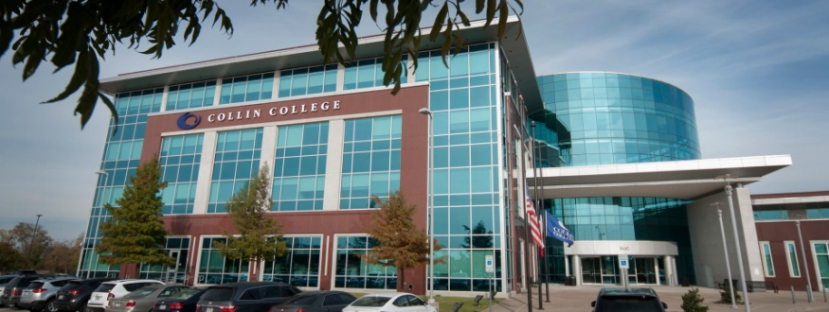 | Collin Higher Education Center  3452 Spur 399 McKinney, TX 75069  Northeast intersection of Highway 75 at 121
This event is co-hosted by
African American Republican Club  Golden Corridor Republican Women  Allen Area Patriots  Plano Republican Women |  | Conner Harrington  Republican Women  Heritage Ranch Republican Club  Collin Strong  Republican Women North Texas

